Table of Contents
Topics
- Abstract
- Introduction
- Background and Related Work
- System Requirements
3.1 Functional Requirements
3.2 Non-Functional Requirements
- System Architecture and Design
- Hardware Design
5.1 Arduino Uno
5.2 Motor Driver (L298N)
5.3 DC Motors and Power Supply
5.4 Ultrasonic Sensor (HC-SR04)
5.5 Infrared (IR) Receiver Sensor (KY-022)
5.6 Pan-Tilt Ultrasonic Sensor Module
5.7 Bluetooth Module (HC-06)
- Software Design
6.1 Arduino IDE and Firmware Logic
6.2 Bluetooth Serial Communication
6.3 Android Serial Bluetooth Terminal Application
- Implementation
7.1 Manual Control Mode
7.2 Autonomous Mode
7.3 IR Remote Control Integration
- Testing and Validation
- Results and Discussion
- Challenges and Limitations
- Conclusion and Future Work
References
Appendices

Access the GitHub repository for this project
https://github.com/AshqarEzz/Multi-Mode-Embedded-Autonomous-Remote-Controlled-Robot-Car

Abstract
Real-time obstacle detection and avoidance are essential functions in mobile robotic systems. This project presents the design and implementation of a multifunctional robotic car with real-time obstacle detection, obstacle avoidance, and wireless control capabilities. The system integrates hardware, software, and communication components using the Arduino platform, Bluetooth technology, and an Android-based mobile application. Arduino Uno serves as the main control unit, processing sensor data and controlling motor movement. The robotic car is equipped with an ultrasonic sensor for detecting obstacles based on distance (45cm in this project). Bluetooth communication allows users to select the operating mode and control the robot’s movement through a mobile application. The car can also be controlled by any remote control with an IR Receiver on the robot car. The robot can operate in both manual and autonomous modes, allowing either user-directed navigation or automatic obstacle avoidance. The developed system demonstrates effective sensor integration, reliable wireless control, and flexible operation, making it suitable for educational and experimental robotic applications.

1. Introduction
In recent years, rapid advancements in electronic and sensing technologies have significantly contributed to the development of intelligent systems designed to simplify daily life. Sensors play a crucial role in modern electronic devices by converting physical phenomena such as distance, motion, and signal input into electrical data that can be processed by control systems. They act as a bridge between the physical environment and electronic devices such as robots, smartphones, and embedded systems. As a result, sensors and communication modules are widely used in applications including industrial automation, healthcare, transportation, and smart control systems.
Robotic systems rely heavily on environmental perception and user interaction to perform tasks effectively and safely. In mobile robotics, obstacle detection and avoidance are essential to ensure reliable navigation and collision-free movement. This capability is commonly achieved using distance-measuring sensors such as ultrasonic sensors, combined with manual control interfaces for flexible operation.
In this project, a remotely and autonomously controlled robotic car is designed and implemented using sensor-based perception and wireless communication. The system utilizes an Arduino Uno microcontroller as the main control unit, an ultrasonic sensor for real-time obstacle detection and avoidance, an infrared (IR) receiver sensor for remote-based manual control, and a Bluetooth module for wireless communication with an Android-based mobile application. The Arduino processes incoming sensor data and user commands to control the robot’s motion through a motor driver circuit.
The robotic car operates in two main modes: user control mode and automatic mode. In user control mode, the robot is manually controlled through an Android application or IR remote, allowing the user to move the robot forward, backward, left, right, or stop. In automatic mode, the robot navigates independently by detecting obstacles and adjusting its direction to avoid collisions. This system demonstrates effective integration of sensing, wireless communication, and embedded control for mobile robotic applications.
The remainder of this report is organized as follows: Section 2 presents the background and related work. Section 3 outlines the system requirements. Section 4 describes the system architecture and overall design. Section 5 details the hardware design of the robotic car, while Section 6 explains the software design. Section 7 presents the implementation process. Section 8 discusses the testing and validation procedures. Section 9 provides the results and discussion. Section 10 highlights the challenges and limitations of the system. Finally, Section 11 concludes the paper and suggests directions for future work, followed by references and appendices.

2. Background and Related Work
Several studies have been conducted on mobile robotic systems focusing on obstacle detection, autonomous navigation, and remote control using embedded platforms. These works demonstrate the growing interest in integrating sensors, wireless communication, and intelligent control in robotic applications.
Pujari et al. [1] designed a robotic system aimed at remote monitoring applications, particularly for household use. The robot utilized a Raspberry Pi 3 as the main controller along with a camera module, Wi-Fi, and Bluetooth technology. Python programming was used to enable real-time video streaming and communication.
Mishi et al. [2] proposed a robotic car controlled using both Arduino Uno and Raspberry Pi. The system incorporated GPS technology to track the robot’s location, and obstacle distances were measured using sensors. Cloud-based data processing was used to enable multi-motion control of the robotic system.
Chakraborty et al. [3] developed a Bluetooth-controlled robotic car equipped with sensors for obstacle avoidance. Communication between a smart device and the robot was established, allowing the robot to be controlled remotely. An ultrasonic sensor was used to prevent collisions, and camera-based monitoring was employed for environmental observation.
Lee et al. [4] presented an autonomous robotic car using Arduino Uno R3 as the control unit. The system utilized an ultrasonic sensor for obstacle avoidance and a Bluetooth module for communication. Additionally, QR codes were used for navigation, and a PID control algorithm was implemented to ensure smooth motion of the robot.
Amareswar et al. [5] designed a robotic system intended for military applications, integrating sensors such as a metal detector and a camera for explosive detection. The system used Arduino Uno, Bluetooth communication, and DC motors for movement.
Premkumar et al. [6] proposed a Raspberry Pi–based robotic arm controlled through an Android application. Python was used for programming the Raspberry Pi, while the Android application was developed in Java. Communication between the robot and the mobile device was established using Wi-Fi.
In contrast to the above studies, this work focuses on the design and implementation of a remotely and autonomously controlled robotic car based on Arduino Uno, utilizing an ultrasonic sensor for real-time obstacle detection and avoidance, along with infrared (IR) and Bluetooth-based user control. The system emphasizes simplicity, reliability, and suitability for educational and experimental robotic applications.

3. System Requirements
This section defines the functional and non-functional requirements of the remotely and autonomously controlled robotic car. These requirements describe what the system is expected to do and the constraints under which it must operate.
3.1 Functional Requirements (What should the system do?)
- FR-1: The system shall control the movement of the robotic car in forward, backward, left, right, and stop directions.
- FR-2: The system shall receive user control commands from an Android-based mobile application via Bluetooth communication.
- FR-3: The system shall detect obstacles in real time using an ultrasonic sensor.
- FR-4: The system shall automatically stop or change direction when an obstacle is detected within a predefined distance.
- FR-5: The system shall support both manual control mode and automatic (autonomous) navigation mode.
3.2 Non-Functional Requirements
(How well must the system operate, and under what constraints?)
- NFR-1: The system shall respond to user commands with minimal delay to ensure smooth and reliable control.
- NFR-2: The system shall operate reliably using battery power for continuous operation.
- NFR-3: The system shall maintain stable Bluetooth communication within a typical indoor operating range.
- NFR-4: The system shall be implemented using low-cost and commercially available hardware components.
- NFR-5: The system shall process sensor data and control signals efficiently within the computational limits of the Arduino Uno microcontroller.

4. System Architecture and Design

The system structure of the developed robotic car using various sensors is shown in Figure 1. In this paper, the robotic car consists of two modes: The user control and Automatic mode. The robot and Android device communicate with each other using Bluetooth technology
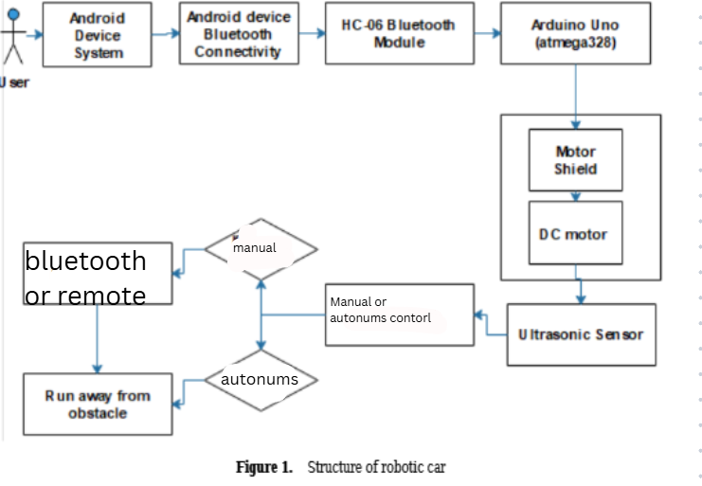

5. Hardware Design
- 5.1. Arduino Uno
Arduino Uno is the robot's brain. Arduino Uno uses the ATmega328 microprocessor. Arduino has 14 pins. The most popular Arduino card is the Arduino UNO model shown in Figure 2. It can be easily programmed with Arduino libraries [7]. Easily programmable is the biggest advantage of other microprocessors. Programming in the Arduino Uno is carried out specifically in the integrated development environment (IDE). The programming language is selected as Embedded C language. Using signals from sensors, it helps to design robots and systems that affect the environment. So, actions happen, such as sound and light, specific to the output of the project.
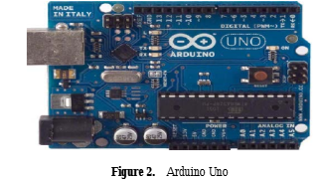
- 4.2. Hc-06 Bluetooth Module
The HC-06 Bluetooth module shown in Figure 3 provides communication between the devices at a short distance of approximately 10 to 20 meters. Communicates with Arduino via Serial Communication (USART). The Bluetooth module can only respond to incoming connection requests, so it can not send a connection request to another Bluetooth module. The Bluetooth module has a total of 4 pins. These are VCC, GND, Rx, and Tx.
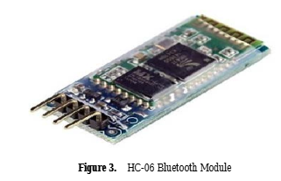
VCC and GND are supplied by Arduino for use in the Bluetooth module. Arduino's Tx pin must be plugged into the Rx part of the Bluetooth module so that commands from the Arduino can be detected by the Bluetooth module. Messages from Bluetooth need to be plugged into the Tx pin of the Arduino's Rx pin Bluetooth module in order to access Arduino [8]. A password is required to connect to the Android device via Bluetooth module.
- KY-022 Infrared Receiver Module
The KY-022 Infrared Receiver module reacts to 38kHz IR light. It can be used to receive commands from IR remote controllers from TVs, stereos and other devices.
It can also be used together with the KY-005 IR Transmitter module.
Compatible with popular microcontrollers like Arduino, Raspberry Pi, ESP32 and others.
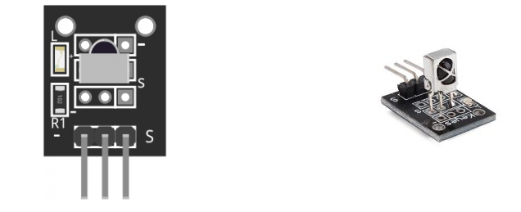
Figure 4. KY-022 Infrared Receiver Module
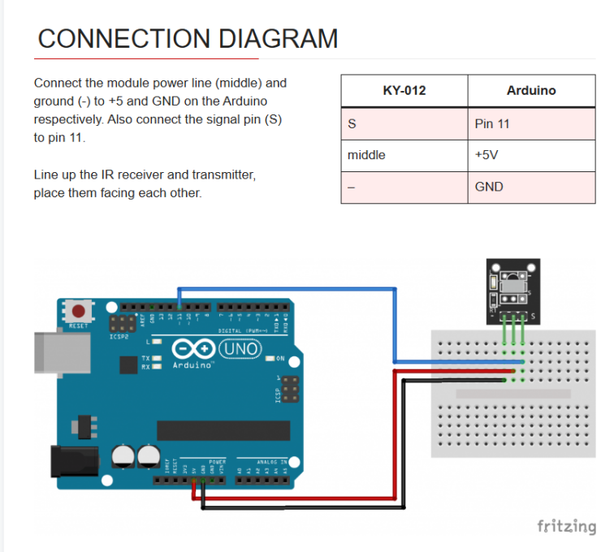

- IR Remote Control
Any remote control can be used to control the KY-022 but in this project this module is being used
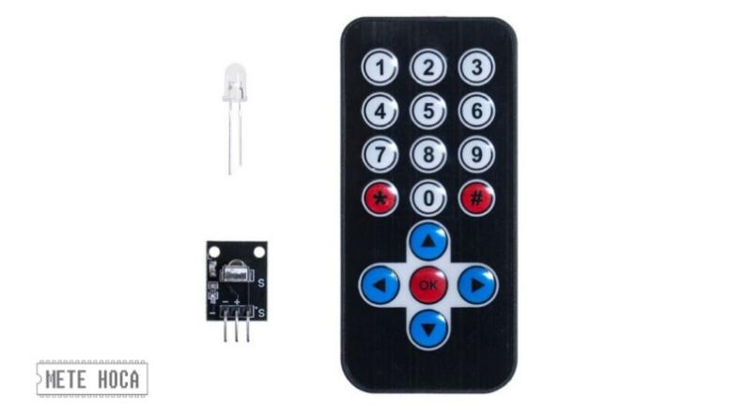
Figure 5. KY-022 remote control

- Uno Sensor Shield for Arduino
Uno Sensor Shield is very useful product which can be used with Arduino boards and designed for stacking many input and output units on board. It is designed for Arduino UNO R3 version and also it can be used with Leonardo or other versions which have same pin layout.
Arduino's all input and output pins on board are in 3-pin sequece in the order of DATA, VCC and GND. Therefore any sensor, servo, relay etc. can be stacked to the board and used easily.

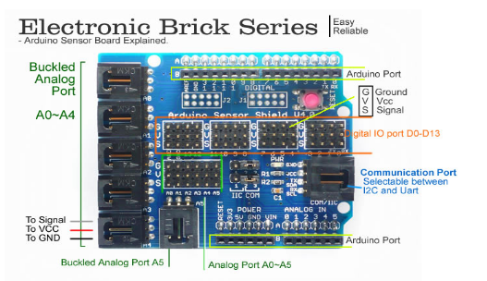
Figure 6. Uno Sensor Shield for Arduino
Also UART and I2C ports are drawn to seperate parts on board for easy useage. "Communication Port" connector can be set as I2C or UART by using jumpers on board.

Uno Sensor Shield is completely compatible with Arduino Uno. It can be used with Leonardo and Mega versions also. But hence I2C and SPI ports are on different pins on these versions, only these ports cannot be used.
All headers and connectors are sent soldered.

- DC Motor

A direct current (DC) motor converts electrical energy into mechanical energy using direct current [9]. A DC motor is an electric machine that operates on the principle that "a current-carrying conductor experiences a force when it enters a magnetic field." The formula for the applied force is F = BIL [10].
The main components of a DC motor consist of 6 pieces. These are coils, magnets, rotors, brushes, a stator, and a direct current source (Figure 7). In this study, the DC motor's purpose is to turn the wheels. The armature is placed in the magnetic field generated by the coils and rotated using direct current, thereby generating a mechanical force.
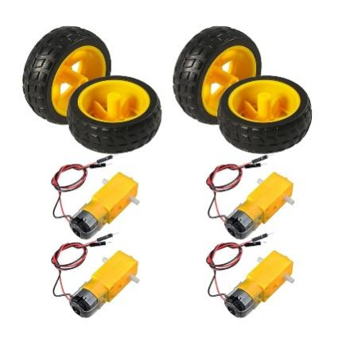
Figure 7. motors and wheels
- Ultrasonic Sensor Hc-Sr04
The HC-SR04 ultrasonic sensor uses Sonar (Sound Navigation and Variable) to calculate the distance to the object. Using sonar, the distance between robot and obstacle are measured. It makes the best measurement between 2- 400 cm. Ultrasonic sound waves have frequencies between 20 kHz and 500 kHz. Ultrasonic sensors are sensors that emit ultrasonic sound waves and can determine the distance between them by calculating the time it takes for them to strike the obstacles (Figure 8).
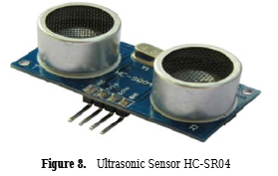
The sensing range of ultrasonic sensors can reach up to 30 meters under appropriate conditions. Ultrasonic sensors have two transducers. One of them is an ultrasonic speaker and the other is an ultrasonic microphone. With the electronic circuit, the time between the propagation of the sound wave from the ultrasonic loudspeaker and the detection of this sound wave by the obstacle and the reflection by the ultrasonic microphone is measured and the distance between the obstacle and the ultrasonic sensor is calculated as a result of dividing this time by the sound speed (Figure 9).
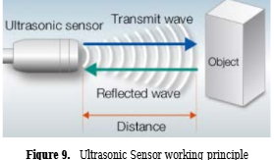

6. Software Design
- Arduino IDE
The Arduino Integrated Development Environment (IDE) is a software development platform used for programming Arduino-based systems. It allows users to write, compile, and upload programs directly to the Arduino Uno microcontroller through a USB connection. The Arduino IDE supports programming in C/C++ and provides built-in libraries that simplify hardware control and sensor integration.
An Arduino program consists of two main functions [9]:
- setup(): This function is executed once at the beginning of the program and is used to initialize variables, pin modes, and communication protocols.
- loop(): This function runs continuously as long as the Arduino board is powered. It contains the main control logic of the system, including sensor reading, decision-making, and motor control.
The Arduino IDE was used to implement the robot control logic, sensor data processing, Bluetooth communication, and mode switching between manual and automatic operation.
2. Android Platform
The Android platform is a Linux-based operating system developed by Google and the Open Handset Alliance. It is an open-source and widely used platform primarily designed for smartphones and tablets. Due to its flexibility and extensive developer support, Android is commonly used in mobile-controlled robotic applications.
The Android operating system is structured into four main layers:
- Linux Kernel:
This layer manages core system services such as memory management, process scheduling, device drivers, and networking.
- Libraries and Android Runtime:
This layer includes system libraries written in C and C++ that provide essential functionalities. The Android Runtime enables applications to run efficiently and acts as an interface between applications and the underlying operating system.
- Application Framework:
The application framework provides high-level services and APIs that developers use to build Android applications, defining the structure and behavior of applications.
- Applications:
This top layer consists of user-level applications that interact directly with users. In this project, a custom Android application was developed to control the robotic car.
Using Bluetooth communication, the Android application sends control commands to the Arduino Uno, allowing the user to manually control the robot’s movement and switch between operating modes.

7. Design and Implementation of the Robotic Car
The robotic car is designed and implemented using an Arduino Uno microcontroller as the main control unit. The hardware components of the system include an HC-06 Bluetooth module, a motor driver module, DC motors, a KY-022 infrared (IR) receiver module with an IR remote control, an ultrasonic sensor mounted on a pan-tilt mechanism, and a 4 × 1.5 V battery pack used as the power supply. The Arduino Uno processes sensor data and user commands to control the movement and behavior of the robotic car.
Wireless communication between the robot and a mobile device is established using Bluetooth technology. The Serial Bluetooth Terminal application is used to transmit control commands from an Android device to the Arduino Uno via the HC-06 Bluetooth module. The application allows predefined character commands to be sent directly over a serial Bluetooth connection.
Before operation, Bluetooth is enabled on the Android device, and the HC-06 module is paired using the default password “1234”. Once connected, the Arduino continuously listens for incoming serial data. Each received character is interpreted as a specific control command, and the corresponding motion or mode operation is executed by controlling the motor driver and actuators.
In addition to Bluetooth control, the robotic car also supports IR remote control using the KY-022 IR receiver module. Commands sent from the IR remote are decoded by the Arduino and mapped to predefined movement or mode operations. This provides an alternative manual control method independent of the mobile application.
The ultrasonic sensor is mounted on a pan-tilt mechanism, allowing it to scan the environment by rotating horizontally and vertically. This configuration improves obstacle detection by enabling the robot to sense objects from different directions rather than a single fixed angle.

User Control Mode and Automatic Mode
The robotic car operates in both manual control mode and automatic (autonomous) mode.
For Bluetooth-based control, the user operates the robot through the Serial Bluetooth Terminal application. A custom interface is configured with eight control buttons, each assigned a specific character value. The command assignments used in this project are as follows:
- Bluetooth Mode: B
- IR Mode: I
- Autonomous Mode: A
- Forward: F
- Backward: B
- Left: L
- Right: R
- Stop: S
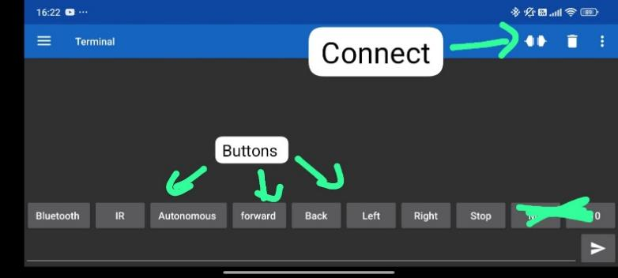
Figure 10. Bluetooth control buttons

In manual control mode, the user can control the robotic car either through the Bluetooth application or the IR remote control. Bluetooth commands are transmitted via the HC-06 module, while IR commands are received through the KY-022 sensor. The Arduino processes these inputs and controls the motors to move the robot forward, backward, left, right, or stop. This mode allows real-time and responsive control of the robot.
In automatic (autonomous) mode, activated by sending the character A, the robot operates independently without user input. The ultrasonic sensor mounted on the pan-tilt mechanism continuously scans the surroundings to detect obstacles. When an obstacle is detected within a predefined distance threshold, the robot stops and changes its direction to avoid a collision. The scanning motion of the pan-tilt system enables the robot to select a clearer path and continue navigation safely.
The power required for the robotic car is supplied by a 4 × 1.5 V battery pack, which provides sufficient voltage for the Arduino Uno, sensors, and motor driver. The system allows seamless switching between manual and automatic modes, offering flexibility and enhanced functionality during operation.

8. Testing and Validation
This section presents the testing and validation procedures carried out to evaluate the functionality, reliability, and performance of the remotely and autonomously controlled robotic car. The goal of testing was to verify that the system meets the defined functional and non-functional requirements, and that all hardware and software components operate correctly under different operating conditions.

8.1 Bluetooth Communication Testing
Bluetooth communication testing was performed using the Serial Bluetooth Terminal application installed on an Android device. The HC-06 Bluetooth module was paired with the mobile device using the default pairing password. After successful pairing, individual command characters were transmitted to the Arduino Uno to verify correct reception and interpretation.
Each movement command (forward, backward, left, right, and stop) was tested multiple times. The robot’s response time and accuracy were observed during operation. The system demonstrated stable communication, and the robot responded correctly to all transmitted commands without noticeable delay or data loss within a typical indoor operating range. Mode-switching commands were also tested to ensure reliable transition between manual and autonomous modes.

8.2 IR Remote Control Testing
The infrared control functionality was validated using the KY-022 IR receiver module and its corresponding IR remote control. The Arduino Uno was programmed to decode IR signals and map them to predefined movement commands. During testing, each remote control button was pressed repeatedly to assess signal reception reliability.
The robotic car consistently responded to IR commands under normal indoor lighting conditions. The system was also tested at different angles and distances between the remote and the receiver. Results showed that the IR control provided a reliable alternative manual control method, particularly in scenarios where Bluetooth communication was unavailable or unstable.

8.3 Ultrasonic Sensor and Pan-Tilt Mechanism Testing
The obstacle detection system was tested using an ultrasonic sensor mounted on a pan-tilt mechanism. The pan-tilt setup allowed the sensor to rotate and scan the environment across a wider field of view. Testing was conducted by placing obstacles of various sizes and materials at different distances and directions relative to the robot.
Distance measurements were observed to ensure that the ultrasonic sensor provided accurate and consistent readings. The pan-tilt mechanism was tested to confirm smooth movement and effective scanning. The system successfully detected obstacles within the predefined threshold distance and provided sufficient spatial information for navigation decisions.

8.4 Obstacle Avoidance Testing
Obstacle avoidance behavior was tested by placing static obstacles directly in the robot’s path. Upon detecting an obstacle, the robot was expected to stop, adjust its direction, and continue moving without collision. Multiple trials were conducted to evaluate repeatability and consistency.
The robotic car successfully avoided obstacles in most test cases. The pan-tilt scanning capability allowed the robot to determine a clearer path by evaluating multiple directions before proceeding. This improved avoidance performance compared to a fixed ultrasonic sensor configuration.

8.5 Autonomous Mode Testing
Autonomous mode was tested by activating the mode using the Bluetooth command interface. Once enabled, the robotic car operated independently without user intervention. The robot was placed in an indoor environment containing multiple obstacles, and its navigation behavior was observed over extended periods.
During testing, the robot demonstrated the ability to navigate continuously while avoiding obstacles and adjusting its path dynamically. The system remained stable during prolonged autonomous operation, confirming the effectiveness of the sensor processing and control logic implemented on the Arduino Uno.

8.6 Mode Switching and System Integration Testing
Mode switching between Bluetooth control, IR control, and autonomous mode was tested to evaluate system integration and stability. The robot was switched between modes during operation to observe any unexpected behavior or system resets.
The results showed smooth transitions between modes, with no observed conflicts between control inputs. This confirmed that the system logic correctly prioritizes user commands and sensor-based control.

8.7 Power Supply and Stability Testing
The power system was tested using a 4 × 1.5 V battery pack to evaluate voltage stability and operational duration. The robot was operated continuously in both manual and autonomous modes until battery voltage dropped below operational levels.
The system maintained consistent performance during normal operation, and no unexpected resets of the Arduino Uno were observed. This demonstrated that the power supply was sufficient for supporting the motors, sensors, and communication modules.
Go to table 1to see Test Case and Validation Table

9. Results and Discussion
This section presents the results obtained from the testing procedures described in the previous section and discusses the overall performance of the robotic car system. The results demonstrate that the system successfully meets the defined functional and non-functional requirements.

9.1 System Performance Results
The Bluetooth communication system exhibited stable and reliable performance during testing. Commands sent from the Serial Bluetooth Terminal application were received and processed correctly by the Arduino Uno, resulting in accurate and responsive robot movements. No significant communication delays or command losses were observed under typical indoor conditions.
The IR remote control system using the KY-022 module functioned reliably and provided an effective alternative control method. The robot responded consistently to IR commands, confirming correct decoding and integration with the main control logic.
The ultrasonic sensor mounted on the pan-tilt mechanism demonstrated accurate distance measurements and improved environmental awareness. Compared to a fixed sensor configuration, the pan-tilt setup allowed the robot to scan a wider area and select safer navigation paths. This significantly enhanced obstacle detection and avoidance performance.

9.2 Autonomous Navigation Results
In autonomous mode, the robotic car successfully navigated environments containing multiple static obstacles. The robot detected obstacles within the predefined distance (45 cm)threshold, stopped appropriately, and adjusted its direction to avoid collisions. The autonomous navigation algorithm proved effective for real-time obstacle avoidance in indoor environments.
The system remained stable during extended autonomous operation, with no unexpected resets or erratic behavior. This indicates that the control logic and sensor processing implemented on the Arduino Uno are suitable for basic autonomous robotic applications.

9.3 Power and Reliability Discussion
The power system using a 4 × 1.5 V battery pack provided sufficient energy for operating the motors, sensors, and communication modules. The robot maintained stable operation throughout the testing period, demonstrating that the power supply was adequate for the system requirements.
Mode switching between Bluetooth control, IR control, and autonomous mode was smooth and did not introduce instability. This confirms that the system integration was successful and that control priorities were handled correctly by the software.

9.4 Discussion and Observations
Overall, the results confirm that the robotic car meets its design objectives. The integration of Bluetooth, IR remote control, and autonomous navigation provides flexibility and usability. The use of low-cost and readily available components makes the system suitable for educational and experimental purposes.
Some minor limitations were observed, such as reduced Bluetooth reliability at longer distances and sensitivity of ultrasonic measurements to surface properties of obstacles. These limitations are discussed further in the next section.

10. Challenges and Limitations
This section discusses the main challenges encountered during the design, implementation, and testing of the robotic car, as well as the limitations of the developed system. These limitations arise primarily from hardware constraints, power management, and communication range.

10.1 Power Consumption and Battery Limitations
One of the main limitations observed during testing was related to power consumption. The robotic car was powered using a 4 × 1.5 V battery pack, which provided sufficient voltage for normal operation. However, after approximately five days of repeated testing, the batteries drained relatively quickly and required replacement. This limitation is mainly due to continuous motor operation, sensor usage, and wireless communication. As a result, battery life restricts the duration of long-term operation without recharging or replacement.

10.2 Motor Driver Power Configuration (L298N)
During implementation, it was observed that the L298 motor driver configuration is highly dependent on jumper settings. The Arduino Uno supplies control signals to the motor driver, and the ENA and ENB jumpers must remain connected to ensure proper motor operation. Additionally, the power jumper located on the top of the L298 power ports must not be removed, as removing this jumper causes the motor driver to stop functioning. This dependency limits flexibility in power configuration and requires careful hardware setup for correct operation.

10.3 Communication Range Limitations
The wireless control of the robotic car relies on Bluetooth communication and IR remote control, both of which have limited operating ranges. When the robot moves outside the effective range of Bluetooth and IR signals, manual control becomes unavailable. In such cases, the system automatically switches back to autonomous mode, allowing the robot to continue operating independently. While this behavior improves safety by preventing uncontrolled motion, it also limits precise user control over longer distances.

10.4 Environmental and Operational Constraints
The performance of the ultrasonic sensor can be affected by environmental conditions such as object surface texture, angle, and surrounding noise. These factors may reduce distance measurement accuracy in certain scenarios. Additionally, indoor testing environments were more suitable for stable operation compared to outdoor environments, where lighting conditions and uneven surfaces may affect performance.

10.5 Summary of Limitations
The limitations discussed above represent practical constraints commonly encountered in low-cost mobile robotic systems. Additional performance observations and experimental results are discussed in Section 9 (Results and Discussion). Despite these limitations, the system successfully achieves its intended objectives within the defined scope of the project.

11. Conclusion and Future Work
In recent years, numerous studies have focused on the development of robotic vehicles using platforms such as Arduino Uno, Raspberry Pi, and Android-based systems. This project presented the design and implementation of a remotely and autonomously controlled robotic car based on the Arduino Uno platform, emphasizing real-time obstacle detection and avoidance using low-cost and readily available components.
The robotic car was successfully implemented with Bluetooth-based remote control, IR remote control, and an automatic (autonomous) mode. Communication between the robot and the Android device was established using the HC-06 Bluetooth module and a Serial Bluetooth Terminal application, allowing the user to control the robot’s movement and switch operating modes wirelessly. The ultrasonic sensor (HC-SR04) mounted on a pan-tilt mechanism enabled effective real-time obstacle detection and improved environmental scanning, allowing the robot to avoid collisions during autonomous navigation.
Experimental results demonstrated that the system performs reliably in both manual and autonomous modes. The robot was able to respond accurately to user commands, detect obstacles within a predefined distance, and adjust its direction accordingly. The integration of multiple control methods increased the flexibility and usability of the system, making it suitable for educational and experimental robotic applications.
Despite the successful implementation, the system has certain limitations, including limited battery life, restricted Bluetooth and IR communication range, and dependence on specific motor driver configurations. These limitations highlight potential areas for improvement.
Future work may focus on enhancing the system by integrating rechargeable batteries or power management circuits to improve energy efficiency, replacing Bluetooth with Wi-Fi-based communication to increase control range, and improving autonomous navigation algorithms. Additional sensors, such as encoders or line-following sensors, may also be incorporated to enhance navigation accuracy and functionality.

References
[1] S. S. Pujari, M. S. Patil, and S. S. Ingleshwar, “Remotely controlled autonomous robot using Android application,” Proceedings of the 2017 IEEE International Conference on I-SMAC (IoT in Social, Mobile, Analytics, and Cloud), 2017.
[2] M. R. Mishi, R. Bibi, and T. Ahsan, “Multiple motion control systems of the robotic car based on IoT to produce cloud service,” Proceedings of the 2017 IEEE International Conference on Electrical, Computer and Communication Engineering (ECCE), 2017.
[3] D. Chakraborty, K. Sharma, R. K. Roy, H. Singh, and T. Bezboruah, “Android application based monitoring and controlling of movement of a remotely controlled robotic car mounted with various sensors via Bluetooth,” Proceedings of the 2016 IEEE International Conference on Advances in Electrical, Electronic and Systems Engineering (ICAEES), 2016.
[4] S. J. Lee, J. Lim, G. Tewolde, and J. Kwon, “Autonomous tour guide robot by using ultrasonic range sensors and QR code recognition in an indoor environment,” Proceedings of the IEEE International Conference on Electro/Information Technology, 2014.
[5] E. Amareswar, G. S. S. K. Goud, K. R. Maheshwari, E. Akhil, S. Aashraya, and T. Naveen, “Multipurpose military service robot,” Proceedings of the 2017 IEEE International Conference on Electronics, Communication, and Aerospace Technology (ICECA), 2017.
[6] Premkumar, Keerthi, and K. Gerard Joe Nigel, “Smart phone-based robotic arm control using Raspberry Pi, Android, and Wi-Fi,” Proceedings of the 2015 IEEE International Conference on Innovations in Information, Embedded, and Communication Systems (ICIIECS), 2015, doi: 10.1109/ICIIECS.2015.7192973.
[7] S. Varshney, B. Gaur, O. Farooq, and Y. U. Khan, “Brain machine interface for wrist movement using robotic arm,” Proceedings of the IEEE 16th International Conference on Advanced Communication Technology (ICACT), 2014, doi: 10.1109/ICACT.2014.6779014.
[8] Geleceği Yazanlar, “Bluetooth ile iletişim,” Available: https://gelecegiyazanlar.turkcell.com.tr/konu/arduino/egitim/arduino-201/bluetooth-ile-iletisim, Accessed: June 20, 2018.
[9] S. Verma, “Android app controlled Bluetooth robot,” International Journal of Computer Applications, vol. 152, no. 9, pp. 35–40, 2014.
[10] Robotpark, “DC motor nedir?” Available: http://www.robotpark.com.tr/Dc-Motor-Nedir, Accessed: June 21, 2018.
[11] “Remote and autonomous controlled robotic car based on Arduino with real time obstacle detection and avoidance,” Available: https://www.researchgate.net/publication/330702209_Remote_and_Autonomous_Controlled_Robotic_Car_based_on_Arduino_with_Real_Time_Obstacle_Detection_and_Avoidance.

Appendices
Test ID | Test Description | Input / Condition | Expected Outcome | Result
T-1 | Bluetooth connection test | Pair HC-06 with Android device | Successful Bluetooth connection | Passed
T-2 | Bluetooth command transmission | Send F, B, L, R, S via Serial Bluetooth Terminal | Robot moves according to command | Passed
T-3 | Mode switching via Bluetooth | Send A command | Robot enters autonomous mode | Passed
T-4 | IR remote control test | Press movement buttons on IR remote | Robot responds correctly | Passed
T-5 | Ultrasonic distance detection | Place obstacle within threshold distance | Obstacle detected accurately | Passed
T-6 | Pan-tilt scanning test | Rotate ultrasonic sensor | Sensor scans multiple directions | Passed
T-7 | Obstacle avoidance behavior | Place obstacle in robot path | Robot stops and changes direction | Passed
T-8 | Autonomous navigation test | Enable autonomous mode in obstacle-filled area | Robot navigates without collision | Passed
T-9 | Mode switching stability test | Switch between IR, Bluetooth, Auto modes | No system crash or reset | Passed
T-10 | Power stability test | Operate using 4×1.5 V batteries | Stable operation over time | Passed
Table (1)Test Case and Validation Table

